Beginner Tutorial: Using YouTube to Learn Python Lists

# 1. How to Access YouTube

Go to https://www.youtube.com using your web browser.

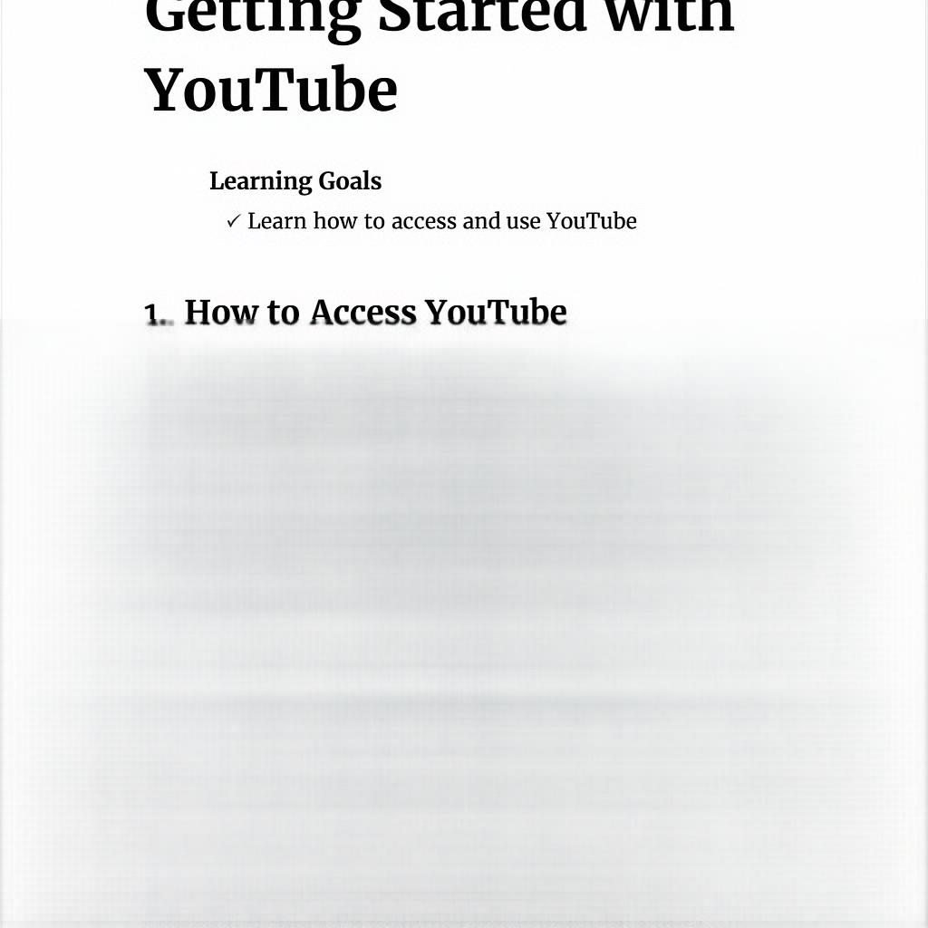

# 2. How to Search for a Video

Type keywords like 'Python Lists for Beginners' in the search bar and press Enter.



# 3. How to Access a Video by URL

Paste the video link (e.g., https://youtu.be/example) directly into the browser's address bar.



# 4. How to Save a Video

Click the 'Save' button below the video to add it to your playlist or Watch Later.

